

#### TITLE OF PROJECT REPORT

**Vehicle Door Open Warning and Locking Safety System**

#### A PROJECT REPORT

***Submitted by***

NITHISHKUMAR N (730221114015)

SATHIK BASHA M (730221114332)

PRADEEP R M (730221114326)

RUPATHI S (730221114330)

in partial fulfillment for the award of the degree in

**BACHELOR OF ENGINEERING**

**IN**

**MECHANICAL ENGINEERING.**

#### AL-AMEEN ENGINEERING COLLEGE

(**An Autonomous Institution affiliated to Anna University, Chennai)**

**ERODE – 638**

### AL-AMEEN ENGINEERING COLLEGE

(**An Autonomous Institution affiliated to Anna University, Chennai)**

##### ERODE – 638

BONAFIDE CERTIFICATE

This is to certify that this Project Report the bonafide work of **NITHISHKUMAR (730221114015), PRADEEP (730221114326), RUPATHI (730221114330)** and

**SATHIK BASHA (730221114332)** who carried out the project entitled. **“VEHICLE DOOR OPEN WARNING AND LOCKING SYSTEM”.**

**SIGNATURE**   **SIGNATURE**

Dr.R.Balusamy, M.E.,Ph.D., Mr.H.Mohammed Aslam, M.E.,

**HEAD OF DEPARTMENT. SUPERVISOR**

Professor. Assistant Professor

Mechanical Engineering Mechanical engineering

AL-AMEEN ENGINEERING COLLEGE. AL-AMEEN ENGINEERING COLLEGE

ERODE – 638. ERODE - 638

Submitted for Viva voice Examination held on

**Internal Examiner External Examiner**

## ABSTRACT

A vehicle door open warning and locking safety system have been introduced to solve the problem of vehicle target collisions that appeared earlier when the driver and passenger. The car door opening alert system includes signal detectors for detection. When a car returns while someone opens the car door, when the Ultrasonic sensor detects another car from behind, Arduino processor will allow the car door control unit to prevent the car door from opening. Visual warning of light and Audio warning of buzzer will be activated. It is activated to provide visual and audible warning signals when the car door is opened and the highest safety provided is the door will be locked with the help of the car door Lock Actuator and will not allow the person to open the door while the vehicle has been detected.

## LIST OF SYMBOLS

**&**

**ABBREVIATIONS**

**IOT** - Internet of Things

**VDOWLS** - Vehicle Door Open Warning and Locking System**.**

**EEPROM** - Electrically Erasable Programmable Read-Only Memory.

**SRAM** - Static Random Access Memory.

**VCC** -- Voltage Common Collector.

## ABLE OF CONTENTS

##### CHAPTER NO

ABSTRACT

##### TITLE

LIST OF FIGURES

LIST OF TABLES

LIST OF SYMBOLS AN ABBREVIATION.

1. INTRODUCTION
   1. Overview
   2. Objectives
   3. IOT technology and VDOWLS
      1. IOT Concept and Definition
      2. IOT in VDOWLS System
      3. Benefits OF VDOWLS System
   4. Methodology
2. LITERATURE SURVEY
   1. Car Door Safety System
   2. Vehicle Door Opening Warning System
   3. Vehicle Door Lock Automation
3. METHODOLOGY
   1. Definition IOT Based VDOWLS System
   2. Components and Modules
      1. Arduino Uno
      2. Ultrasonic Sensor
      3. Bread Board
      4. USB Cable 2.0
      5. Car Door Lock Actuator
      6. Dc to Ac Converter
4. RESULTS AND DISCUSSION
5. **CONCLUSION AND FURTHER ENHANCEMENT**

References Appendix

1. Source Code
2. Screenshots and Output

**1.1OVERVIEW**

## CHAPTER 1 INTRODUCTION

Due to the rapid development of technology and user interest in driving safety, vehicle safety technology is becoming increasingly popular. Due to the high incidence of motor vehicle accidents in recent years, driving safety is one of the hottest and the most worrying. The support system has the potential to improve the quality of road transportation and reduce driving entertainment. In the future, driving assistance will play an important role in protecting drivers and passengers and preventing accidents.

The World Health Organization reports that more than 120 million people die each year in road accidents, and recently 5 billion people have disabilities. For many years, little attention was paid to the area behind the vehicle before opening the doors leading to oncoming vehicles, including oncoming vehicles and bicycles.

This resulted in primary and secondary damage to the front-wheel drive driver, which accounted for 11.6% of the total number of people with disabilities, delayed access to the lane and leads to falls, with 5.3% of all deaths. Work Technology that can prevent these accidents. Scientists and experts use vision and radar technology to determine the purpose of entering the warning zone behind the car.

The present invention has been accomplished under the circumstances in view. It is one object of the present invention to provide a vehicle door opening warning system, which gives audio and visual warning signals when the car door is being opened. It is another object of the present invention to

provide a vehicle door opening warning system, which limits the opening angle of the car door when a sensor at the car door senses the approaching of a car from behind.

1.2.OBJECTIVE

A vehicle door open warning and locking safety system have been introduced to solve the problem of vehicle target collisions that appeared earlier when the driver and passenger. The car door opening alert system includes signal detectors for detection. When a car returns while someone opens the car door, when the Ultrasonic sensor detects another car from behind, Arduino processor will allow the car door control unit to prevent the car door from opening.

Visual warning of light and Audio warning of buzzer will be activated. It is activated to provide visual and audible warning signals when the car door is opened and the highest safety provided is the door will be locked with the help of the car door Lock Actuator and will not allow the person to open the door while the vehicle has been detected.

A door opening assistant for a motor vehicle is specified. This comprises an environment sensor system for monitoring at least the lateral area of a vehicle, a device for detecting an opening of a vehicle door or the intention of a vehicle occupant to open a door or an already opened door, an evaluation unit for carrying out a situation analysis, wherein it is evaluated whether at least an environment object is located in a danger area to the side of the vehicle or will enter the area within a predetermined time and a warning or a door locking device to prevent the opening of the vehicle door when at least one environment object is in the danger zone or could enter the danger zone.

##### IOT TECHNOLOGY AND VDOWLS:

###### IOT concept and Definition:

Internet of things IOT consists of two words Internet and Things The term things in IOT refers to various IOT devices having unique identities and have capabilities to perform remote sensing, actuating and live monitoring

##### IOT TECHNOLOGY AND VDOWLS:

* + 1. IOT concept and Definition:

Internet of things IOT consists of two words Internet and Things The term things in IOT refers to various IOT devices having unique identities and have capabilities to perform remote sensing, actuating and live monitoring of certain sort of data. IOT devices are also enable to have live exchange of data with other connected devices and application either directly or indirectly, or collected data from other devices and process the data and send the data to various servers.

The other term internet is define as Global communication Network connecting Trillions of computers across the planets enabling sharing of information .Thus the IOT can be define

**1.3 IOT TECHNOLOGY AND VDOWLS:**

1.3.1 IOT concept and Definition:

Internet of things IOT consists of two words Internet and Things The term things in IOT refers to various IOT devices having unique identities and have capabilities to perform remote sensing, actuating and live monitoring of certain sort of data. IOT devices are also enable to have live

exchange of data with other connected devices and application either directly or indirectly, or collected data from other devices and process the data and send the data to various servers.

locking the door with a door lock actuator and preventing someone from opening the door when the car is detected.

#### METHODOLOGY:

The most typically technology was microwave radar based mostly sensors, that were generally mounted within the rear bumper and observe vehicles that were along with or slightly behind the vehicle.

When an automotive return whereas someone opens the automotive door, once the un hearable device detects another car from behind, Arduino processor can enable the door management unit to forestall the car door from opening.

# CHAPTER 2

### LITERATURE SURVEY

* 1. Project Title: Car Door Safety System, Google Patents, 2019

**Objective:**

The present invention relates to a safety device for automobiles and, more particularly, to a safety device for preventing the door of an automobile from accidentally slamming on a person's hand or fingers.

Techniques:

Interfacing sensors Zig-Bee modules Camera

Actuators with small scale controller and raspberry.

Advantages:

* A first switch means disposed on an exterior side of the automobile door;
* A second switch means disposed on an interior side of the automobile door;
* A control circuit responsive to the first and second switch means; and
* A door closure preventing means effective for preventing automobile door from fully closing in response to a signal from the control circuit, the control circuit being effective to normally activate the door closure preventing means when the automobile door is in an open state

and to disable the same when either the first or second switch means is held in an activated state.

###### Disadvantages:

* It’s expensive to use in actual field although it’s automotive and quick process.
* It causes weakening of radio recurrence (RF) signals by the organization of sensors dirt.

#### Project Title: Vehicle Door Opening Warning System, IEEE IoT Journal, 2019

###### Objectives:

The present invention relates to vehicle safety and pre-warning technology and more particularly, to a vehicle door opening warning system, which gives audio and visual warning signals when the car door is being opened, and limits the opening angle of the car door when a sensor at the car door senses the approaching of a car from behind.

###### Techniques:

Arduino Technology, Image Sensor.

###### Advantages:

* + - A first switch means disposed on an exterior side of the automobile door,
    - A second switch means disposed on an interior side of the automobile door.

Disadvantages:

* + - It’s expensive to use in actual field although it’s automotive and quick process.

###### 2.3 Project Title: Vehicle Door Lock Automation, Springer IoT Conference paper,

Objectives:

The present invention relates generally to a safe remote-control door opening-and-closing device for an automotive vehicle and more specifically to a safety device for a remote control door in which the door will not be opened or closed if a passenger is in an abnormal sitting position within the passenger compartment, or in which the door being closed will be opened again if a passenger is between the door and the vehicle

Techniques:

Arduino Technology,IR Sensing Technology

# 

# CHAPTER 3

### METHODOLOGY

* 1. DEFINITION IOT BASED VDOWLS SYSTEM

The most typically technology was microwave radar based mostly sensors, that were generally mounted within the rear bumper and observe vehicles that were along with or slightly behind the vehicle.

When a automotive returns whereas someone opens the automotive door, once the un hearable device detects another car from behind, Arduino processor can enable the door management unit to forestall the car door from opening.

Visual warning of light and audio warning of buzzer will be activated. it's activated to produce visual and hearable warning signals when the door is opened and also the highest safety provided is that the door are going to be latched with the assistance of the automotive door Lock mechanism and will not enable the person to open the door whereas the vehicle has been detected.

* 1. COMPONENTS AND MODULES:

In this section, various components and Modules being used for Vehicle door open warning and locking safety system.

* ARDUINO UNO,
* ULTRASONIC SENSOR,
* LOCK ACTUATOR, (V)
* CAR TAIL LIGHT, (V)
* AUDIO BUZZER. (V)
* DC TO AC CONVERTER, (V)
  + BATTERY. (V)
    1. ARDUINO UNO:

The Arduino Uno is a microcontroller board based on the ATmega328 (datasheet). It has

14 digital input/output pins (of which 6 can be used as PWM outputs),6 analog inputs, a

16 MHz crystal oscillator, a USB connection, a power jack, an ICSP header, and a reset button. The Arduino uno is a microcontroller board based on the ATmega1280 (datasheet). It has 54 digital input/output pins (of which 14 can be used as PWM outputs),

* DC TO AC CONVERTER, (V)
* DOOR CONTROL UNIT, (V)
* BATTERY. (V)

The power pins are as follows:

* **VIN.** The input voltage to the Arduino board when it's using an external power source (as opposed to 5 volts from the USB connection or other regulated power source). You can supply voltage through this pin, or, if supplying voltage via the power jack, access it through this pin.
* **5V.** The regulated power supply used to power the microcontroller and other components on the board. This can come either from VIN via an on-board regulator, or be supplied by USB or another regulated 5V supply.

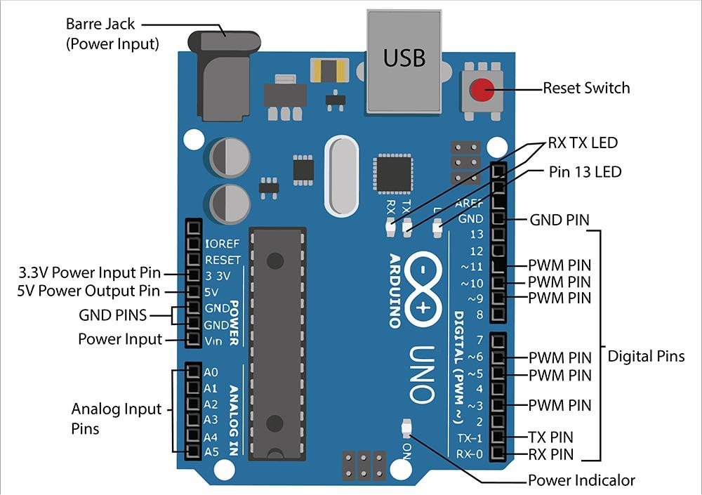

* + 1. ULTRASONIC SENSOR:

An ultrasonic sensor is an electronic device that measures Ultrasonic waves travel faster than the speed of takes between the emission of the sound by the transmitter to its contact with the receiver. The formula for this calculation is **D = ½ T x C** (where D is the distance, T is the time, and C is the speed of sound ~ 343 meters/second). For example, if a scientist set up an ultrasonic sensor aimed at a box and it took 0.025 seconds for the sound to bounce back, the distance between the ultrasonic sensor and the box would be about 10.2875 meters.

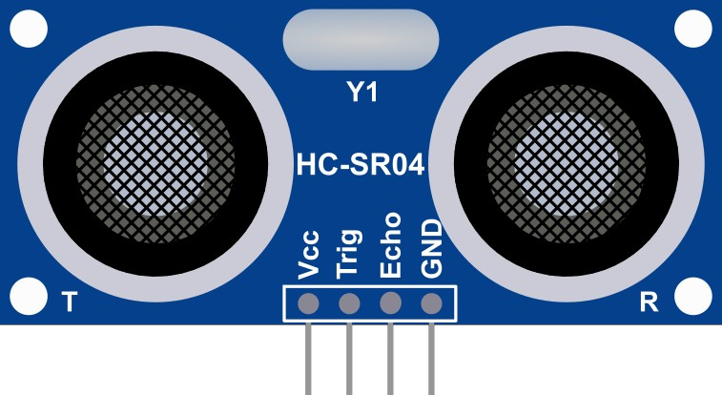

Ultrasonic Sensor (HC-SR04)

Distance = Speed × Time

The Ultrasonic transmitter transmits an ultrasonic wave, this wave travels in air and when it gets objected by any material it gets reflected back toward the sensor this reflected wave is observed by the Ultrasonic receiver module as show

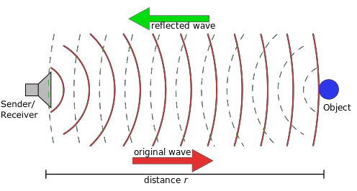

**Ultrasonic Sensor (T/R)**

* + 1. BREAD BOARD:

Breadboard is equipment that is used for connecting integrated circuits and registers. It helps to test and build circuit connection.

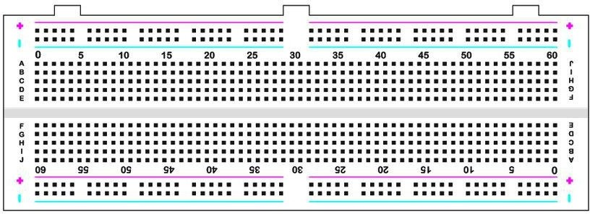

**Bread Board V2**

##### USB CABLE:

Arduino USB 2 Serial Micro. With the Arduino USB Serial micro get the 5-volt TX

and RX lines from a computer USB port that you can connect straight to the Arduino Mini

05 or to other microcontrollers for programming or data communication The USB cable connects the Arduino hardware with the power supply mode here in our case we use PC.

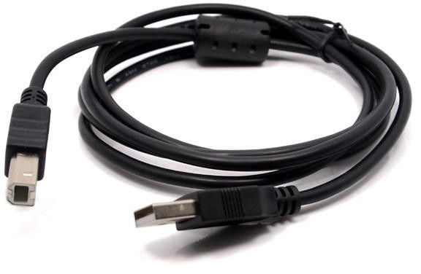

###### USB Cable 2.0

* + 1. CAR DOOR ACTUATOR:

Door lock actuators are an electronic component found on vehicles equipped with power door locks. They are the electronically controlled actuators in every single door that are responsible for locking and unlocking the power door locks when the switches are pressed.

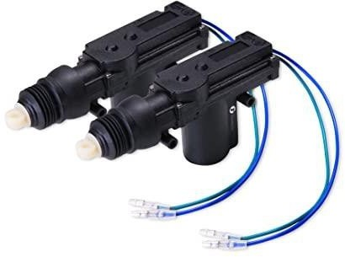

**Car Door Lock Actuator**

* + 1. DC TO AC CONVERTER:

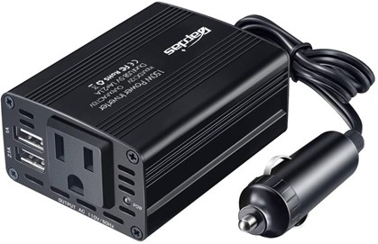A power converter is an electrical or electro-mechanical device for converting electrical energy. A power converter can convert alternating current (AC) into direct current (DC) and vice versa; change the voltage or frequency of the current or do some combination of t.

**CHAPTER 4**

##### RESULTS AND DISCUSSION

A door opening assistant for a motor vehicle is specified. This comprises an environment sensor system for monitoring at least the lateral area of a vehicle, a device for detecting an opening of a vehicle door or the intention of a vehicle occupant to open a door or an already opened door, an evaluation unit for carrying out a situation analysis, wherein it is evaluated whether at least an environment object is located in a danger area to the side of the vehicle or will enter the area within a predetermined time and a warning or a door locking device to prevent the opening of the vehicle door when at least one environment object is in the danger zone or could enter the danger zone.

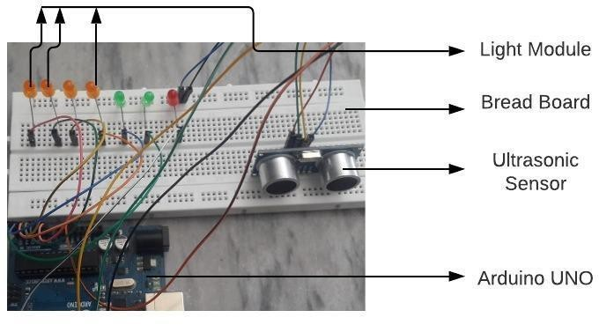

VDOWLS System Module Circuit

highest safety provided is that the door are going to be latched with the assistance of the automotive door Lock mechanism and will not enable the person to open the door whereas the vehicle has been detected.

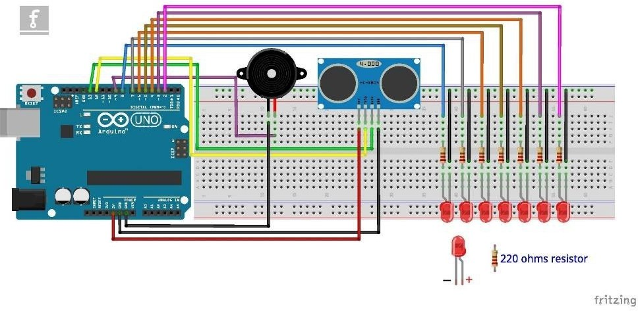

Graphical Representation of VDOWLS System Module Circuit

As shown above the HC-SR04 Ultrasonic (US) sensor is a 4-pin module, whose pin names are VCC, Trigger, Echo and Ground respectively. This sensor is a very popular sensor used in many applications where measuring distance or sensing objects are required. The module has two eyes like projects in the front which forms the Ultrasonic transmitter and Receiver.

A car door opening warning system includes a car door opening control unit installed in a car door hinged to a car

##### CHAPTER 5

**CONCLUSION AND FURTHER ENHANCEMENT**

The experimental results illustrate that the proposed Vehicle Door Open Warning and Locking System can provide high vehicle detection accuracy and give warning to driver effectively for driver assistance and collision warning.

This active safety technology will provide a safety to the vehicle and the appearing vehicle from collision and will reduce the accidents caused by these kinds of unexpected activities at the highest rate.

The present invention has been accomplished under the circumstances in view. It is one object of the present invention to provide a vehicle door opening warning system, which gives audio and visual warning signals when the car door is being opened. It is another object of the present invention to provide a vehicle door opening warning system, which limits the opening angle of the car door when a sensor at the car door senses the approaching of a car from behind.

#### 

#### APPENDIX

B. SOURCE CODE:

int const trigPi= 10; int const echoPin = 9; int const buzzPin = 2; int const ledPin = 4; int const actPin = 5;

void setup()

{

PinMode(trigPin, OUTPUT); pinMode(echoPin, INPUT); pinMode(buzzPin, OUTPUT); pinMode(ledPin, OUTPUT); pinMode(actPin, OUTPUT);

}

void loop()

{

// Duration - input pulse width, distance - distance to the obstacle int duration, distance;

digitalWrite(trigPin, HIGH);

//high - 1 delay(1);

// time deley in ms digitalWrite(trigPin, LOW);

//low - 0

duration = pulseIn(echoPin, HIGH); distance = (duration/2) / 29.1;

//amount of sound travels in 1 min = 29.1ms if (distance <= 50 && distance >= 0) {

digitalWrite(buzzPin, HIGH); digitalWrite(ledPin, HIGH);

igitalWrite(actPin, HIGH);

} else

{

digitalWrite(buzzPin, LOW); digitalWrite(ledPin, LOW); digitalWrite(actPin, LOW);

}

delay(5); 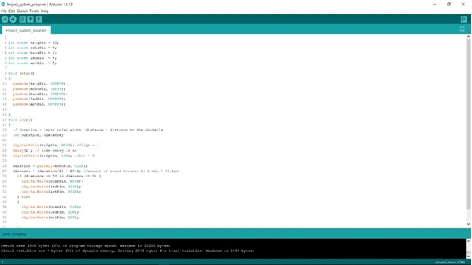

SCREENSHOTS AND OUTPUT:

**System Test Module**

